Structure & Functions of Various Department of Newspaper Organization
Admin February 25, 2017 Media Management
Newspaper organization has various departments taking care of a variety of tasks. Each department has a specified function with several staff taking care of each function. Various departments that are a part of a newspaper organization include:
1. Editorial department
2. Advertising department
3. Circulation department
4. Printing department
5. Administrative department
6. Stores department
7. IT department

Let us discuss the functions of these departments in brief
EDITORIAL DEPARTMENT
The editorial department forms the backbone of any newspaper organization. As the name implies, this department is the one responsible for content creation in any newspaper establishment. The main responsibilities of this department is the gathering of news, selecting which news and features get to be published in the paper, editing the news and features that have been selected for publication and then laying them out for print. Following chart represents the hierarchy of the department followed by a brief description of the functions performed by various staff members.

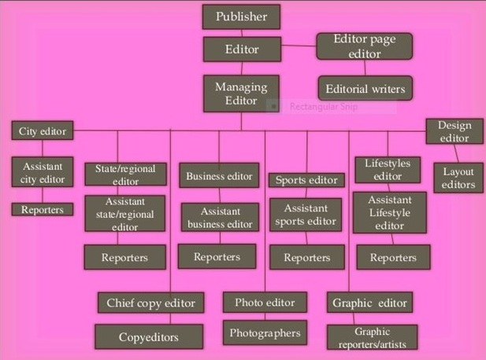

Publisher- The publisher is responsible for all of the operations of the newspaper, both editorial and business. The main job of the publisher is to see that the newspaper remains financially healthy.
Editor- The editor is responsible for all of the editorial content of the newspaper and for the budgets and money spent by the editorial side of the newspaper. Often in smaller papers, the publisher and editor is the same person.

Editorial page editor- The editorial page editor is responsible for the editorial page and the "op-ed" page of the newspaper. These pages are where the newspaper's editorials are printed as well as letters to the editor, columns by syndicated columnists and guest columns by local people.
Managing editor- This is the person who is in charge of the day-to-day production of the newspaper.
City Editor- The city editor -sometimes called the metro editor -is in charge of the news coverage of the area in which the newspaper is located. The city editor usually has the largest staff and assigns tasks to most of the local news reporters.

News reporter- A news reporter gathers information about news stories in the local area. There are generally two kinds of reporters: i) a beat reporter, and ii) a general assignment reporter.
A beat reporter covers the same subject or location all the time. The subject is generally of interest to the reporter. Various beats include legal reporting, parliamentary reporting, political reporting, etc. A general assignment reporter, on the other hand, covers any story assigned by the city editor or assistant city editor.

Chief copy editor- The chief copy editor is in charge of the newspaper's copydesk. The people on the copydesk read news stories (and sometimes stories from other sections) to make sure they are written according to the newspaper's standards. The chief copy editor makes final decisions about the copy and is in charge of the staffing of the desk.

Copy editor- A copy editor is specially trained to read the stories that others have written and make sure they conform with the rules of grammar and style. A copy editor also writes headlines and performs other duties that help produce the newspaper every day.

Photo editor- A photo editor is not a photographer, although it is often the case that the photo editor is a former photographer. This editor assigns photographers and helps select the photos that the newspaper prints.

Graphics editor- The graphics editor is the head of the graphics department, sometimes called the "art department." This editor is in charge of all of the graphics and illustrations produced for the newspaper.

Graphics reporter- A graphics reporter researches and designs informational graphics that support news stories the paper. A graphics reporter is an expert in graphic forms and also must be able to local information that can be used to build graphics.

ADVERTISEMENT DEPARTMENT
As an integral mass media vehicle, newspapers are vehicles of advertising meant to appeal to their readers. As such, the advertising department is the one which is critical because it gets in the revenue necessary to sustain the newspaper. Getting in revenue through advertising for the newspaper happens through various means. There can be several sections in this department one to look after local advertising, one for classified ads, one for general / national advertising, one for legal advertising and yet another one for preparing copy and so on. For example, there is a complete sales team in place, whose job it is to push the newspaper as an advertising vehicle of choice to advertising and media buying agencies acting on behalf of clients, as well as clients.
The Advertising department will accept and process orders from advertisers, to book space in the newspapers, as well as create ads, give agencies statistics and information about the circulation and readership of the newspaper as well, as well as work with the editorial teams to create space, the department carries out a number of functions, including accepting and processing orders from advertisers, creating advertisements, providing media information to advertisers and advertising agencies, helping businesses develop advertising plans and working with editorial teams to develop features that will attract advertisers or help clients place their products with a coordinated editorial write up.

CIRCULATION DEPARTMENT
The circulation department takes care of everything after the newspaper is printed. This includes delivering the publication to homes through their own or third-party carriers, to the post office to be mailed into homes, as well as to newsstands, vending machines, and other places it's circulated.
It is usually headed by a major executive, the circulation manager, since the newspaper ultimately stands or falls on the basis of the number of steady readers that can be enrolled.
The circulation manager may have any or all of the following subdivisions under his supervision:
(i) City Circulation: It involves the maintenance of circulation records for the city of publication; the recruitment, supervision and reimbursement of carrier boys; the: supervision of district men who oversee circulation by subdivisions of the city, taking responsibility for moving papers to the news-stands, relations with news-stand operators, etc.
(ii) Area Circulation:Responsibilities here include getting papers destined for the surrounding area into the mail and operation of a fleet of tempos/taxis to carry the papers into surrounding areas where mail service is not rapid enough.The circulation manager is also in charge of moving the papers into the appropriate distribution channels as they move into the mailing room from the press room.
(iii) Sales Promotion: It involves the direction of an office staff to keep records, notifying subscribers when their subscriptions need renewing, the handling of complaints, new subscriptions and renewals over the counter, by mail, etc.
Promotion is essentially the "public relations" department of the newspaper. Where a separate promotion department exists, it usually is responsible for initiating promotion policies, subject to the approval of the publisher, and usually coordinates the promotional activities of other departments.

PRINTING DEPARTMENT
This is another department in a newspaper establishment whose name simply tells people the job that they perform. This department is responsible for the printing of the newspapers. The department is in charge of everything that has to do with the production and printing of the papers, which includes, transforming journalists’ stories into type and maintaining the printing machines.

ADMINISTRATIVE DEPARTMENT
This department is responsible for the general administration of the entire establishment. The department is in charge of certain very important duties such as planning, organizing and staffing.Thus, the department basically looks after the general administrative work pertaining to personnel their selection, training, promotion, allotment of work, maintaining leave record, liaison with government departments, general facilities and all such work that facilitates working of other departments. In the absence of a separate legal department the administrative department also handles the work pertaining to legal matters. Otherwise there is a separate department for the legal aspects.

STORES DEPARTMENT
This is a department that has one sole responsibility which is to properly store newsprint and all the raw materials used for printing. They also store all other materials that are used in the establishment.

IT DEPARTMENT
This department is in charge of protecting, maintaining, and improving the technical equipment associated with running a media outlet. Engineers/technicians spend some of their time on preventive maintenance and trying to keep equipment from breaking and much more of their time fixing equipment that has already broken. This last job is especially important, considering that the high cost of new technology makes it difficult to replace equipment. Like the production/printing department, this department is not a part of the news department but still plays an important part in the newscast.
This department is mostly headed by the Chief Engineer. He/She is responsible for all operations and maintenance that has to do with any and all engineering equipment used throughout the organization. Chief engineer has to manage and maintain complex integrated systems with minimum supervision and maintain and repair of all technical equipment in the organization. This position requires the ability to troubleshoot, diagnose and handle the tools necessary to repair newsroom equipment and effectively present information and respond to question from managers, clients, customers and public. A solid working knowledge of the latest gadgets, computers, hardware, parts and related software with practical knowledge of electrical, plumbing and basic construction techniques is helpful. Chief Engineer presides over ground-keeping technician.

